1ST ANNUAL FESTIVAL OF TREES

We are looking for local businesses/families/organizations to participate in our 1st annual festival of trees. December 12th 10am to 7pm, December 13th 10 am to 7pm, and December 14th 10 am to 5pm.
What is the purpose of a festival of trees? The purpose of a festival of trees is to raise money for an organization. This year the money will be going to the Limington fire / rescue department for some new equipment.
How could you help us? We need every business, family, or organization to bring an artificial tree, gift basket, or tabletop tree.
You provide lights, decorations and unwrapped gifts around the tree.
If you are doing gift certificates, gift cards, or cash please photocopy and use the photocopy in your display. give us the real items. We will lock them up with the name on them of what tree it goes with. We would not want them to get lost or stolen.
You come in and set the tree up and give it a name. We will have 2 times available the week before. Wednesday the 10th and Thursday the 11th from 3pm to 8pm
You give us a list of everything under and / or on the tree so we can display it with the tree. Some people love to do theme trees. Some examples are Legos, camping, pets, kitchen, hot wheels, barbie, games, crafting, and more.
We will hand out a flyer at the door with the number, and names of the tree and who sponsored that tree.
How does the fundraising part of this work? At each tree there is a bucket to drop your ticket into. We will sell these tickets for 3 days. At the end of day 3 we draw a winning ticket. We call the winner, and they keep everything the tree, the décor, and everything under and on the tree. They will have 48 hours to pick up their items.
Attached is the promissory note of your participation, and some examples of what others have done.

Thank you so much for your support in this fun and exciting fundraiser to help our community.

We will need 100% commitment by November 15th. So, we know how many spaces we have taken up. We only have 8 small tree spaces, and 8 gift basket spaces, and 30 big tree spaces.
We will commit to the 2025 1st annual festival of trees. I understand the guidelines listed on this paper and the attached paper.
Please mail to: Limington Rec Department, PO Box 240, Limington Maine 04049
Or drop off @ Limington tow hall attn: Madison Moody
Name of your tree/ basket you want displayed

Name of business/organization____________________________________________
Contact person _____________________
phone number _____________________
Contact E mail ______________________________________________
Large tree _______ Small tree __________ Gift basket ____________
(please put the # of each one you will commit to)
What time and day will you be setting up? _____________________
_______________________________________________________________

There is no limit as far as price goes on these trees and the decorations and stuff around the trees

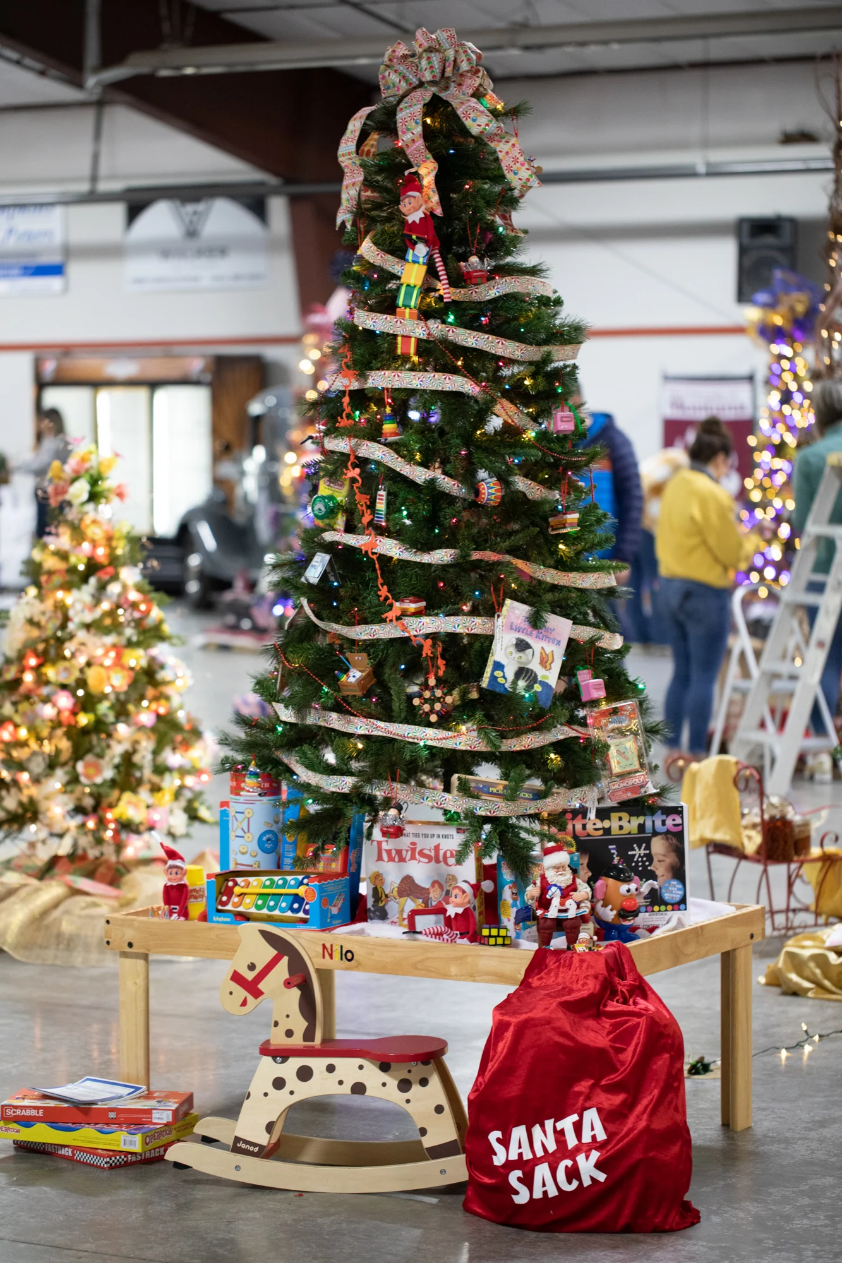
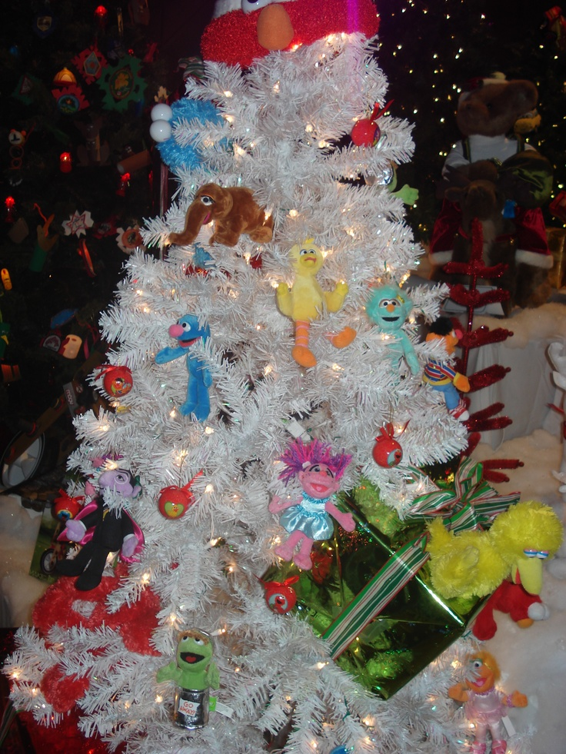

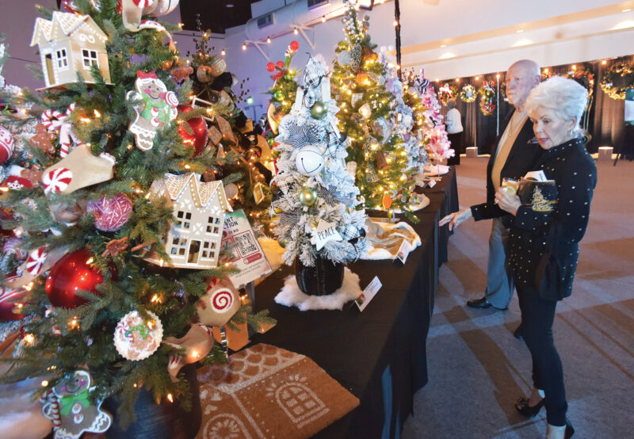
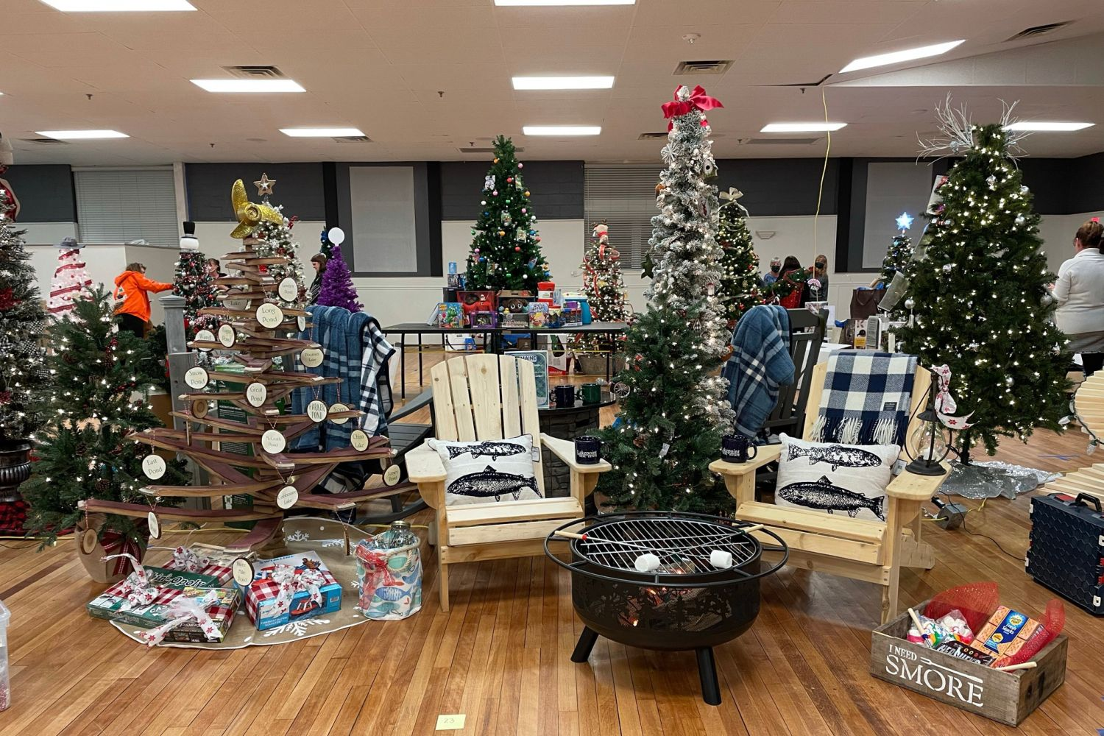
These are just some examples!

